

CENTENNIAL COLLEGE PROGRESS CAMPUS

COURSE COMP213 Fall 2024

ASSIGNMENT #3

Select a product that you really like (example: a TV set, a laptop, a car, etc.)

Find information about your favourite product on the Internet.

Using the product information (picture, description, features, similar products, company that sells the product), create an HTML page with content ***similar*** to the following screenshot of a typical product online page:

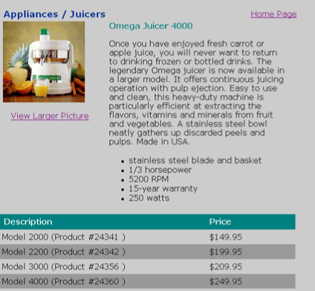

**Required Features:**

* **Design the page layout to fit a 1024px screen (width:980px) and show the content centered on the screen.**
* **Choose appropriate font families that look good on the screen (Hint: use a sans serif font for the main text on the page).**
* **Use an HTML table to list the product types and prices.**
* **Add a banner for your page (not shown in above picture) to include a product-related picture, the product company logo hyperlinked to their website, some title text.**
* **Save the HTML page as Assignment3.html.**
* **When you click the “Home Page” hyperlink, redirect the browser to your home page (index.html) on studentweb.**
* **When you click the “View Larger Picture” hyperlink, open another document called details.html, that displays a detailed (larger) picture of your product and a “back” hyperlink to the product info page.**

* **Create an HTML comment within your document that shows your name and student number**.
* **Upload your Assignment3.html and details.html documents to the studentweb server, and update the “Assignment 3” hyperlink to it from your index page. Remember to upload the picture files to the server too.**
* **Upload a zip file with all html and image files to the Assignment 3 drop-box in e-centennial.**

**See e-centennial for the due date.**